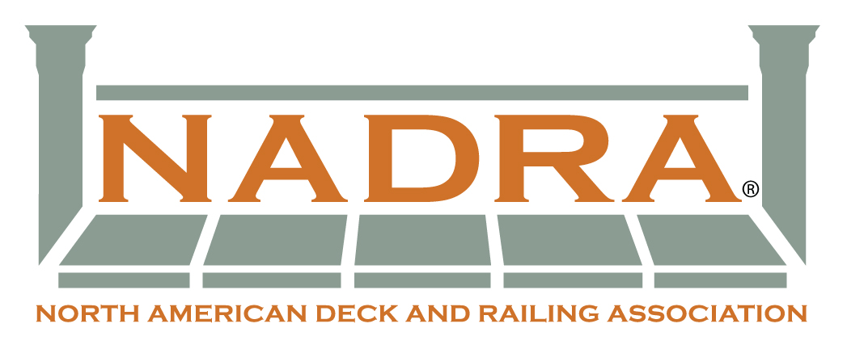
Deck For A Soldier News Release

Contact: (YOUR NAME, EMAIL, PHONE)

LOCAL SOLDIER GETS MAJOR HOME UPGRADE FROM DECK FOR A SOLDIER® PROGRAM
(YOUR COMPANY) teams with NADRA to donate all labor, materials for new deck

(CITY, STATE – DATE) (NAME OF SOLDIER) was the most recent beneficiary of the Deck for a Solider® program, sponsored by the (CHAPTER NAME) of The North American Deck and Railing Association (NADRA).

(YOUR COMPANY), a deck builder based in (LOCATION), along with a group of additional deck builders, suppliers and vendors – all members of NADRA – worked to add a (NUMBER)-square-foot deck to (SOLDIER’S NAME)’s home in (TOWN WHERE HOME IS LOCATED). The new outdoor living area was installed at no cost to the soldier.

Deck for a Solider® is an initiative designed to provide deserving service men and women with a “thank you” that both enhances their lifestyle and expresses NADRA’S appreciation for the service and dedication of our armed forces. NADRA, a national trade association, seeks to raise awareness of safe building practices and deck safety.

A volunteer force of contractors, suppliers and other members of NADRA donated time, materials and craftsmanship to complete (SOLDIER)’s new deck.

“It was an honor to give the (SOLDIER’S NAME) family a token of our appreciation for his sacrifice, and an outdoor living space they can enjoy,” (YOUR NAME) of (YOUR COMPANY) said. “Our entire crew of volunteers did an outstanding job.”

For more information on (YOUR COMPANY), visit (YOUR WEBSITE). For information on NADRA, or to nominate a member of the military for the Deck for a Soldier® program, visit www.NADRA.org.

# # #

{YOUR COMPANY} Include a brief description here of your company and location. Include your website.

About NADRA The North American Deck and Railing Association (NADRA) is a not-for-profit trade association made up of deck builders, manufacturers, dealers/distributors, wholesalers, retailers, and service providers to the deck and railing industry. NADRA emphasizes safe building practices and deck safety. NADRA launched Deck for a Soldier® in 2007 to express NADRA’S appreciation for the service and dedication of our armed forces. Deck for a Soldier® was created in response to a query on the NADRA website from a returning soldier. Since then, the Deck for a Soldier® program has provided decks for service men and women in many parts of the country. For information, visit www.NADRA.org.

